【活动方案】
南京市文靖东路小学第一次英语教研活动暨
第七周英语学科全脑课堂教学范式推进方案
活动主题：
深化全脑教育理念的贯彻，以激发学生全脑思维为宗旨，推进全脑英语课堂范式为目标。通过本次活动，落实对全脑英语课堂的改革，有效引导我校英语教师聚焦学生全脑思维核心问题，提高学生语用能力，不断提升英语学科教学质量。
组织：
秦小玮
时 间：2019年4月2日（星期二）上午
地 点： 四年级6班
具体安排：全脑英语课题核心组成员
时 间 | 具体内容 | 授课/主讲教师 | 地 点
第3节 | 《Drawing in the park》 | 丁倩 | 四（6）
第4节 | ◆教研组和课题组教研 | 秦小玮 | 四（6）
拍照、撰写报道：一年级备课组
文靖东路小学数学教研组
2019年4月2日
【活动报道】
英语教研组第一次全脑课堂展示课暨教研活动
4月2日上午，文靖东路小学第一次全脑英语展示课如期进行，本次活动由四（5）班丁倩老师带来《Unit4 Drawing in the park》。
上课前，丁倩老师准备充分，教具丰富，生动又吸引人的板贴非常符合四年级孩子的学习特点，而在动态生成的板贴带领下，同学们仿佛真的进入了那个风景优美的公园，与Mike和Tim一起完成了一场写生。课堂上，同学们争先恐后举起小手，参与度非常高。丁老师的brain rest环节给出清晰明了富有节奏感的chant，再配上她生动活泼的肢体语言，一下就吸引了所有同学与听课老师的注意力，轻松将同学们从单纯的文本学习中解放出来，这一点非常符合全脑的教学理念。丁老师本节课全脑元素贯穿始终，既联系了学生生活实际，又激发了学习兴趣，让学生通过全脑学习方式来提高口语交际能力；用发现、合作、交流等方式来让学生获取知识，激发了学生的参与意识和积极性，同时培养了学生学习英语、应用英语的实践能力。
课后，听课老师们齐聚301，针对这次全脑课堂进行了深入研讨，一致肯定了丁老师清晰的教学思路，良好的语言素养，精彩的教学环节。同时秦小玮老师也提出了关于全脑课程更多的策略环节，力求全脑课程的不断优化，让每位老师都收获了属于自己的思考。

【活动照片】

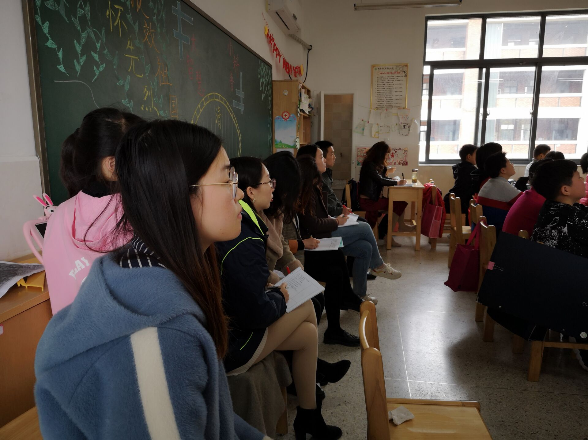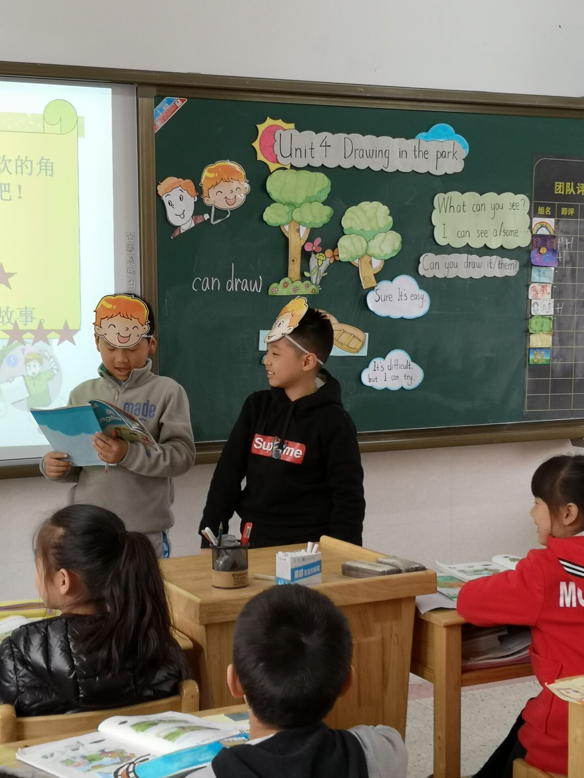

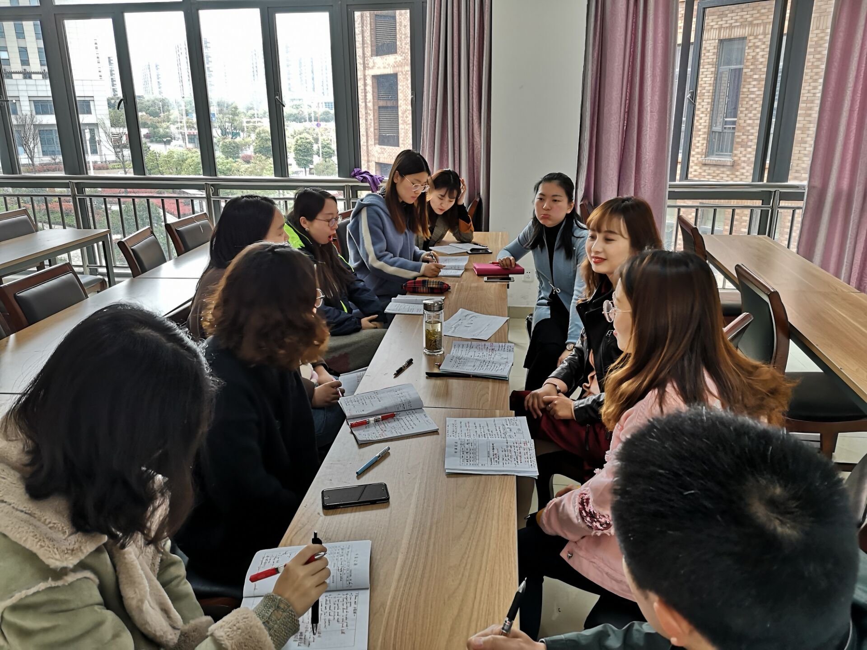

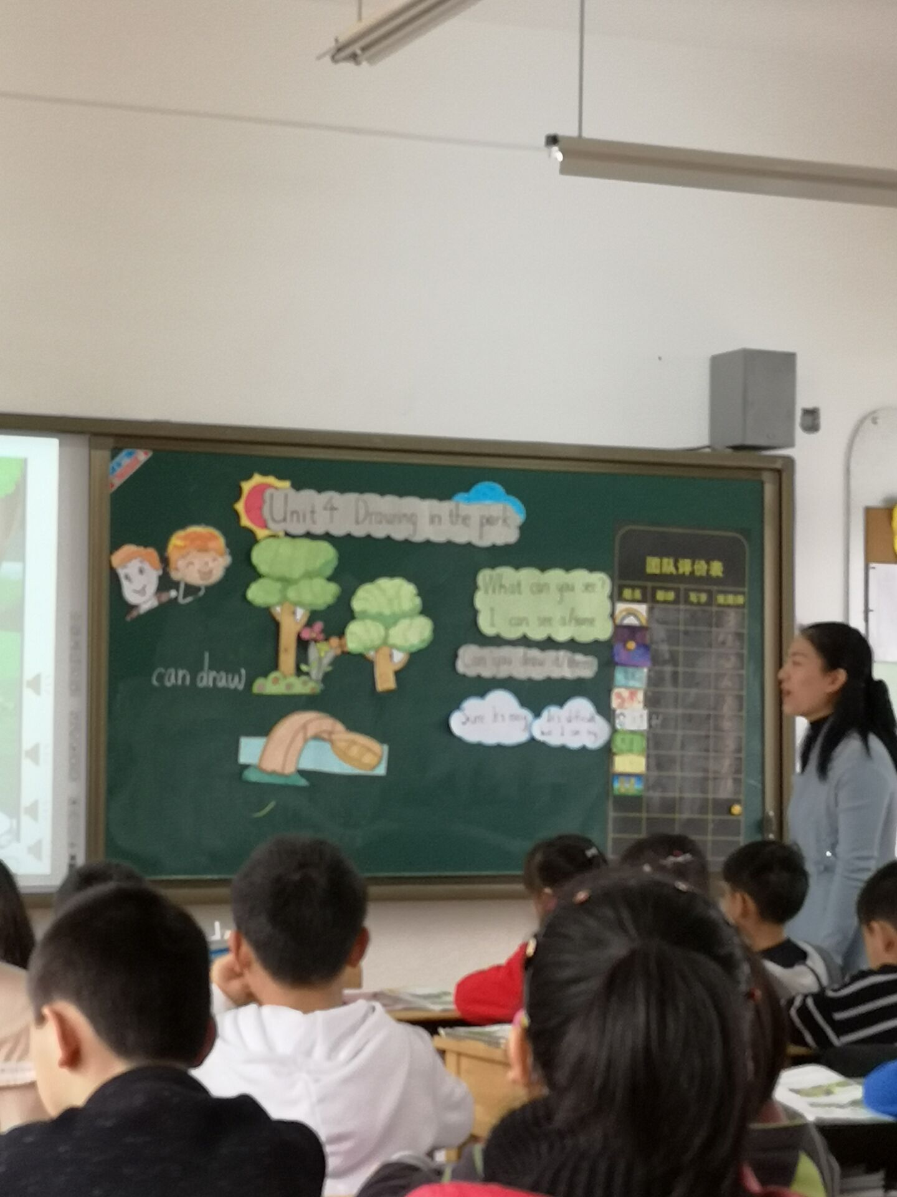
【教学设计及讲稿】
课 题 |  | Unit4 Drawing in the park
教学目标 |  | 1. 能听懂、会说、会读单词：draw, drawing, picture, park, flower, boat, river, lake, easy, difficult., them, hill, again  2. 能听懂、会读、会说日常交际用语：Good idea！Sure, it’s easy. It’s difficult, but I can try.  3. 能初步用以下句型 What can you see? I can see …来对看到的事物进行交流；初步用句型Can you …? 询问交流会做的事。  4. 能正确理解课文内容。  5. 能够较准确的朗读课文并在教师的指导下尝试表演。
重点难点 |  | 1. 能听懂、会说、会读单词：draw, picture, park, flower, boat, river, easy, difficult.  2. 能听懂、会读、会说日常交际用语：Good idea！Sure, it’s easy. It’s difficult, but I can try.  3. 能正确理解、朗读课文内容并能在教师的指导下进行表演。
课前准备 |  | 1.CD 2. 人物头饰 3.Cards 4. PPT
课时安排 |  | 六教时
第 （ 一 ） 课 时 (Storytime)
课时目标 |  | 1. 能听懂、会说、会读单词：draw, picture, park, flower, boat, river, easy, difficult.  2. 能听懂、会读、会说日常交际用语：Good idea！Sure, it’s easy. It’s difficult, but I can try.  3. 能正确理解、朗读课文内容并能在教师的指导下进行表演。
教 学 过 程（初备） |  |  | 修 改
Step1. Warming up
1. Greetings.
2. Free talk.
T: What day is it today?
What subjects do you like?
What can you do at a PE lesson?
Can you play games at a PE lesson?
Do you like playing games. Let’s play a game.
引导教学Good idea.
Step 2. Presentation
1. Play a game “Magic eyes”
示Rules, Read: I can see ...
2. T: Look, these pictures are all mine. I draw them.
Learn: draw
T: I can draw a tree, I can draw some monkeys. What can you draw?
Ss: I can draw ...
T: Where can we draw?
示图 T: We candraw in the park, near the river, in the classroom, at home. We can draw everywhere.
Learn: park, river
教 学 过 程（初备） |  |  |  | 修 改
3. 示图 T: Look, Who are drawing?(Mike and Tim)
Where are they drawing?
Watch and choose. A. Drawing in the park
B. Drawing on the farm
相机揭题。
4. T: Look, this is a park. What can you see in the park?
S: I can see ...
Learn: tree, flower, boat
引导学生描述：The tree is .../The flowers are .../ The ...
T: So we can see a tree, some flowers, a boat and a river in the park. How nice! So Mike and Tim would like to draw in the park.
5. Listen and tick.
T: What does Tim draw?
He draws ...(引导回答)
6. T: Can Tim draw them well?
Learn: them
Read and judge.
- 示图1. T: Are they happy? So Mike says ‘Let’s ...’
Listen and read. What does Tim say?
Reaad in roles.
- 示图2. How does Mike ask? What ...?
Listen and read “I can see ...” Ss try to say the sentence.
Ss guess: Can you draw _____? Spell: them
Sure, it’e ______? easy
理解： “them” means “the tree and flowers”
“easy” means “not difficult”
(3) T: Can Tim draw them well? How do you know?
Try to read: This is the tree and these are the flowers.
Well done.
(4) 示表格。T: Can Tim draw the tree /flowers well? Why?
Try to say: It’s easy to draw a ______ and some _______.
T: How about the boat?
(5) 示图4. Ss try to read the sentences./ Listen and repeat.
Ss guess: Can you draw _____?
理解：the boat on the river
A. 小船在河面上
B. 在河面上的小船
difficult = not easy
T: Look, Mike is confused. How does he say?
Read: Is this a boat? Listen and repeat.
Read it with action.
(6) 示表格。T: Can Tim draw the boat well? Because ...
It’s _________ to draw a boat.
7. Read after the tape/ by themselves.
8. Let’s show.
Work in pairs
教 学 过 程（初备） |  |  |  | 修 改
A.Read in pairs. B. Act in pairs. C. Read together. D. ...
Step 3. Summary
Step 4. Exercise
Mike and Tim are d_____ in the p_____. They can s___ a tree, some f_____ and a b____.Tim can d____ a t_____ and some flowers. It’s e____. But he c_____ draw a boat. Because it’s too d_____.
Step 5. Let’s enjoy
Enjoy the pictures and remember: Enjoy every season. Enjoy every day. Enjoy our life.
Step 6. Homework
作业设计 | Homework  - Read and imitate the story after the tape. And try to make a new story.  - Prepare the Fun time and Song time.
板书设计 | Unit4 Drawing in the park  Mike What can you see? Tim I can see ...  Can you draw them/it? Sure, it’s easy.  It’s difficult, but I can try.
教学后记

【活动签到】
